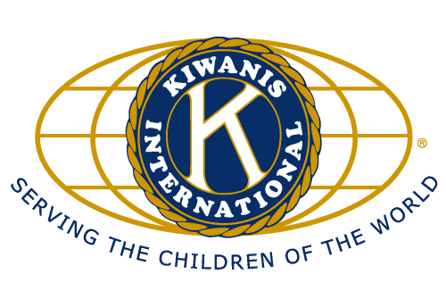
Kiwanis Club of
New Hyde Park- Floral Park
P.O. Box 917
New Hyde Park, NY 11040

Chrissy Oliva, President
Mary Jo Bursig, Secretary

May 2014
Dear Friend:

The Kiwanis Club of New Hyde Park-Floral Park and the County Seat Kiwanis Club will be co-hosting a Night At The Races event on Friday, June 13, 2014 at 6:30pm. This event will be held at the
New Hyde Park Elks Lodge located at 901 Lakeville Road in New Hyde Park (intersection of Bryant Avenue and Lakeville Road).

We would greatly appreciate if you would consider supporting the community and charitable endeavors of our Kiwanis Club by taking a placemat ad or sponsoring the Night At The Races. The placemat ads are $25 for a business card size ad and $40 for a double size ad. The placemats will be placed on every table. Alternatively, you may sponsor the event with a donation of $100. Event sponsors will be recognized with a sign at the Event. If you would like to sponsor the Event or take a placemat ad, please complete the following information and return with your business card and check payable to the “NHP Kiwanis Foundation” in the enclosed envelope by Friday, June 6, 2014. The Kiwanis Club New Hyde Park Foundation Inc. is a registered 501(c)3. All contributions are 100% tax-deductible.

All proceeds from the Night At The Races will be used for community service projects, our sponsored youth and charitable causes. Please help us make our small corner of the world a better place.

Thank you for your support!

Rich Nicolello, Vincent Scott, John Gridley & Pat Farrell
Night At The Races Sponsor Committee
- - - - - - - - - - - - - - - - - - - - - - - - - - - - - - - - - - - - - - - - - - - - - - - - - - - - - - - - - - - - - - - - - - - - - - - - - - -
I would like to support the Night At The Races by:

___ Sponsoring the Event ($100).

___ Taking a business card size placemat ad ($25).

___ Taking a double size business card placemat ad ($40).

Name _________________________________________________

Organization _________________________________________________

Address _________________________________________________

Email _________________________________________________

Please make checks payable to the “NHP Kiwanis Foundation”,
include business card, and mail to
P.O. Box 917, New Hyde Park, NY 11040
THANK YOU!

