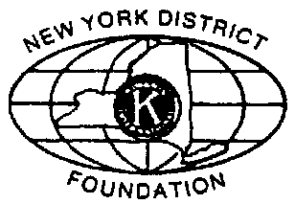
Adopt an Acre Program
The Adopt an Acre program is designed to provide working capital for Kamp Kiwanis. In recognition of adopting an acre the recipient will have an engraved plaque and an engraved brick placed on the wall of the Dining Hall at Kamp Kiwanis which is updated annually.

Date ____________

_______________________________________________________________________
Division or Company

_______________________________________________________________________
Club and/or Person (purchaser)

_______________________________________________________________________
Address (for viewing prior to engraving of commemorative brick)

_______________________________________________________________________
City, State, Postal-code (for viewing prior to engraving of commemorative brick)

The Price of Adopting an acre at Kamp Kiwanis is $1500.00

The Brick to be placed on the Governor’s Hall and Dining Hall can comprise of a maximum of 20 spaces per line and a maximum of six lines. Please write the inscription below that you would like placed on the brick and show line breaks, be sure of spelling.
________________________________________________________________________________________________________________________________________________________________________________________________________________________________________________________________________________________________________________________________________________________________________________________________

Make your checks payable to: New York District Kiwanis Foundation Brick Program
Send this form and your check to: New York Distict Kiwanis Foundation
9020 Kiwanis Road, Taberg, NY 13471
Tel: 315-336-4568 Fax: 315-336-3845
kamp@kiwanis-ny.org www.kiwanis-ny.org/kamp
Revised 1/2009

